trijsturi Rihards Jastržemskis

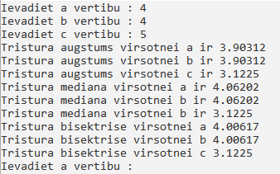

d= √(6.5\*(6.5-4)\*(6.5\*4)\*(6.5-5)=13

p = (0.5 \* 4) + (0.5 \* 4) + (0.5 \* 5)=2+2+2.5=6.5

ha=2\*13/4=3.90312

Ma = 0.5\* √(2\*42+2\*52-42)= 4.06202

Ba = (2 \* ( √((4 \* 4 \* 6.5) \* (6.5 - 5)))) / (4 + 4)=4.00617